
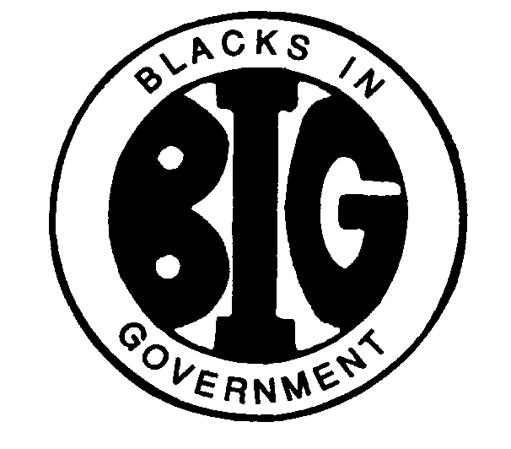
REGION IV BLACKS IN GOVERNMENT
ALABAMA FLORIDA GEORGIA KENTUCKY MISSISSIPPI
NORTH CAROLINA SOUTH CAROLINA TENNESSEE

2025 EXECUTIVE COMMITTEE MEETING
REGION IV COUNCIL PRESIDENT’S REPORT
April 28, 2025

Name/Position: Honorable Alice D. Mercer, Region Council President
E-Mail Address: presidentregiv@gmail.com
Cell Phone: (803) 439-1607

I. RESPONSIBILITIES.
Shall preside over meetings of the Regional Council and serve as chair of the Executive Committee; shall be an ex officio member of all committees except the Nominating, Election and Finance Committees; shall appoint the Parliamentarian, Historian/Librarian, and committee chairs, with the exception of the Finance Committee chair, subject to the approval of the Executive Committee; shall guide the implementation of policies which have been approved by the Regional Council; shall recommend to the National Board of Directors changes in policies and procedures as directed by the Regional Council; shall present the Region's annual report in writing at the annual meeting held in the Fall; shall countersign with the Treasurer or Assistant Treasurer (in the absence of the Treasurer) checks drawn on the Regional Council Treasury; shall receive reports on activities from the chapters; shall ensure notification to chapters of Regional meetings; and shall perform such other functions and exercise such other authorities as may be prescribed by the Executive Committee or Regional Council.

II. ACTION ITEMS:
- All Reports for the May 31, 2025, Spring Council Meeting must be submitted no later than May 1, 2025, to Secretary Peterson. These reports will be sent to Chapter Presidents on May 3, 2025.
- Approval of 2025 Regional Training Conference Registration Package
- Approval of DSHOF Nominee on May 15, 2025, due to National May 21, 2025

III. ACTIVITIES:
Vision: Member-focused, world-class enterprise, recognized for excellence.
Theme: Building on the Legacy of the Flagship Region
Initiative:
- Membership (recruiting, retaining, reclaiming)
- Advocacy (EEO, DEIA, meeting the needs of our communities)
- Career Development (Retirees mentor/role models, training on mock interviews, resume writing, leadership)
- Coalitions/Partnership (create a list of Black Organizations)
Activities
- March 27, 2025, sent out Call for Amendments to the Region IV Bylaws with a suspense date of April 15, 2025, no proposed amendments were received.
- April 3, 2025, held Roundtable Discussion with the National Board of Directors Chair, Honorable Toni Pearson
- April 12, 2025, Conducted Chapter Officer Leadership Training
- April 26, 2025, attended CDC’s Youth Competition and National Future Leaders in American Summit in Atlanta, Georgia
- Region IV Survey was sent out to the Membership during the need assessment due to the impact of new administration.
- Continue to work with Communication and Public Relations Chair on updating the Region IV website to include a member only session and updated materials.
- Biweekly Thursday Regional Prayer starting on May 8, 2025, 2nd Vice President Dr. Brown will lead this event.
- Upcoming Executive Committee Meeting Schedule:
  - May 15, 2025
  - July 28, 2025
  - September 22, 2025
  - November 24, 2025

Status from the following Officers:
- Honorable Mary Peoples, Executive Vice President- to generate ways and means to raise funds and write Position Papers
- 1st, Ira Thompson 2nd, Dr. Shereka Brown, and 3rd , Michele Smith, Vice Presidents to coordinate with Committee Chairs regarding Memberships (recruit, retain and retore) and established programs to addresses issues and concerns at all levels of government.
- Secretary, Kimberly Peterson- research a translation to ensure minutes are done in accordance with the Regional Bylaws and Policies and Procedures Manual. Tracking all Council Meeting actions assigned to the Executive Committee.
- Assistant Secretary, Ernestine Frazier- contact Chapters President for their 2025 Officers and contact information (attached). Research a translation software to ensure minutes are done in accordance with the Regional Bylaws and Policies and Procedures Manual as well as give the Executive Committee Report during the Regional Council Meeting and track all Executive Committee actions.
- Treasurer to prepare the 2024 Treasurer’s books for audit. The audit will be conducted by Abe Joseph (Mr. Jospeh will report out during the Executive Committee Meeting). --completed

VI. ACTIVITIES/ACTIONS THAT SUPPORT BIG'S STRATEGIC PLAN

- Communication Flow:
  - Conducted Leadership training for Executive Committee
  - Individual met with Executive Committee members.
  - Coordinating with the Communications and Public Relations Chair to update the Regional Website to incorporate email addresses to Region IV Members
- Financial Accountability:
  - Contacted Ade Jospeh to conduct an email of Region IV finance.

- Advocacy:
  - Reviewed President Trump Executive Orders.
  - Discussed Executive Orders with regional members

- Membership:
  - Establish a membership portal on Website.
  - Coordination with 1st, 2nd, and 3rd Vice Presidents, Membership Chair and Programs and Planning Chair to develop strategies to increase membership.

