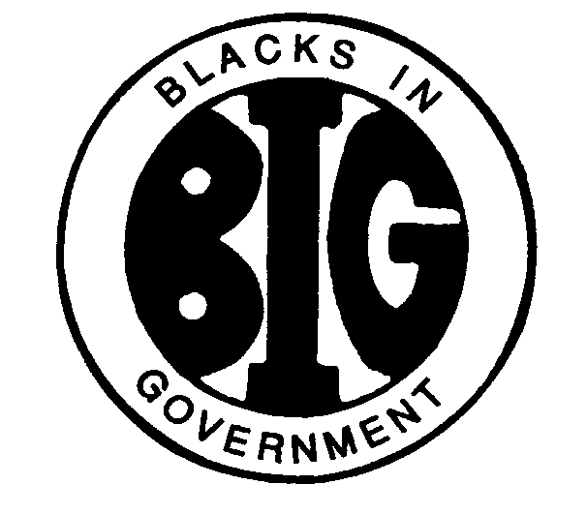
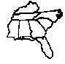
REGION IV BLACKS IN GOVERNMENT
ALABAMA FLORIDA GEORGIA KENTUCKY MISSISSIPPI
NORTH CAROLINA SOUTH CAROLINA TENNESSEE

Region IV Health & Wellness Coordinator

Health and Wellness Update
September 12, 2022

Name: Mary L. Beal
E-Mail Address: mlbeal.mb@gmail.com
Cell Phone: (229) 401-8308

I. RESPONSIBILITIES

Health and Wellness. The Health and Wellness Committee shall develop and coordinate comprehensive on-going activities that educate the general membership on health care access, prevention, treatment, insurance, finding opportunities and health risk factors that affect the African American community; increase the level of awareness and understanding of initiatives on the elimination of race and ethnic health disparities nationwide; exchange information on healthy lifestyles that lead to reducing the risk of HIV/AIDS, diabetes, cardiovascular diseases, cancer, homicide, mental disorder, lupus, obesity, and infant mortality; help to foster partnerships within the African- American communities, including survivors.

II. ACTION ITEMS
- Review and approve proposal to negotiate non-profit fundraising agreement with Care Beyond Company.
- Approval a virtual health and wellness training program for Region IV
- Request access to Region IV membership roster(s) for the purpose of sending invitation to participate in health and wellness training.

III. ACTIVITIES

Participate on a local Health & Wellness Coalition that include members from Georgia Department of Public Health and local healthcare providers.

Attended an informative webinar on Mental Health issues in the workplace

Analyzed health and wellness database compiled by the University of Wisconsin Population Health Institute.

Reviewed Health and Wellness ranking by state/county:
- KIDS COUNT ® is a project of the Annie E. Casey Foundation
- State Level Data and Rank (County Health Rankings and Roadmaps)
- Reviewed the database prepared by the University of Wisconsin Health Population Institute for 2021 County Health Rankings and determined that it served as a viable tool for planning and delivering health and wellness information to members and citizens in Region IV.
- I propose to conduct monthly and or quarterly ZOOM presentations on specific health and wellness topics for Region IV. I have developed some health and wellness training modules that should not conflict with any agenda from the national office. As knowledge increases, I envision adding more modules.

BIG Region IV
Proposed Health & Wellness Publicity and Training 2022
Total No of Counties | State | Targeted Counties | Target First | Target Second
67 | Alabama | 27 | 13 | 14
67 | Florida | 28 | 11 | 17
159 | Georgia | 69 | 27 | 42
120 | Kentucky | 44 | 21 | 23
82 | Mississippi | 32 | 14 | 18
100 | North Carolina | 45 | 19 | 26
46 | South Carolina | 22 | 8 | 14
95 | Tennessee | 41 | 15 | 26
736 |  | 308 | 128 | 180

Scheduled ZOOM training for next quarter will be at 11AM EST:
- Training Dates
October 15, 2022
November 12, 2022
December 18,2022

- Registration for Health and Wellness Training will be required

- ZOOM Links will be sent via email or text upon registration

IV. CONCERNS / FYI

- Level of leadership focus on health and wellness
- Request for volunteers to assist with Regional Health & Wellness Training Events
- Lack of focus on health and wellness by leadership in Region IV
- Request Health and Wellness contact information for each Region IV Chapter.
- Leadership must be on board to encourage others to participate.

V. INFORMATION AND HEALTH AND WELLNESS RESOURCES

www.countyhealthrankings.org
https://datacenter.kidscount.org

Attached EXCEL File on Targeted Region IV Counties. Counties affected by contaminated water will be added later to the list by state.

