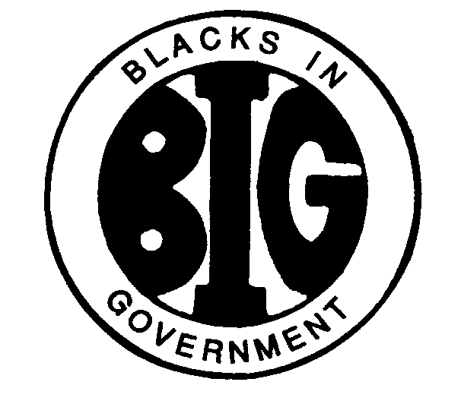



**REGION IV BLACKS IN GOVERNMENT**

***ALABAMA FLORIDA GEORGIA KENTUCKY MISSISSIPPI***

***NORTH CAROLINA SOUTH CAROLINA TENNESSEE***

Executive Committee Meeting

## BYLAWS COMMITTEE REPORT

**April 21, 2025**

Names: Al Taylor, Magnolia Chapter (Chair); Famous Johnson, East Central Savannah River Chapter, Arnold Taylor, First Mississippi Chapter, Cardell Hunt, Kings Bay Area Chapter, Ruby Dunson, Okaloosa County Chapter, Katie Course, Magnolia Chapter and Terrence Jones, CDC/ATSDR Chapter

E-Mail Address: queart2@aol.com

Cell Phone: (601) 201-1528

1. **RESPONSIBILITIES**

The Bylaws Committee shall render constitutional opinions to the Executive Committee and the Regional Council; shall periodically review the Regional Bylaws and the National Constitution and recommend amendments where appropriate; shall offer opinions on the constitutionality of all policies; and shall be responsible for incorporating all approved amendments into the Regional Bylaws and distribute them to the Chapters within thirty (30) days through the Regional Council President.

1. **ACTION ITEMS**

There are no action items from the committee currently.

1. **ACTIVITIES**

The Region IV Council President sent the call for proposed bylaws amendments to Region IV Chapter Presidents for distribution on March 28, 2025. The deadline for submitting proposed bylaws amendments to the Council President was April 15, 2025.

1. **INVITATIONS & EVENTS**

The Region IV Council President shall send all proposed Region IV Bylaws amendments to all chapters by May 1, 2025, (30 days prior to the next Council meeting) according to Article XVIII of the existing Region IV Bylaws.