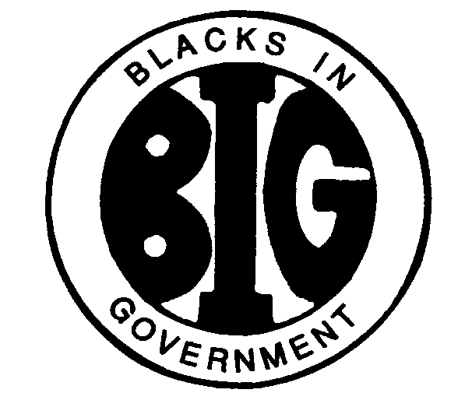
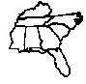
REGION IV BLACKS IN GOVERNMENT
ALABAMA FLORIDA GEORGIA KENTUCKY MISSISSIPPI
NORTH CAROLINA SOUTH CAROLINA TENNESSEE

Executive Committee Meeting

BYLAWS COMMITTEE REPORT
February 26, 2024

Names: Al Taylor, Magnolia Chapter (Chair); Famous Johnson, East Central Savannah River Chapter and Arnold Taylor, First Mississippi Chapter
E-Mail Address: queart2@aol.com
Cell Phone: (601) 201-1528

- RESPONSIBILITIES

The Bylaws Committee shall render constitutional opinions to the Executive Committee and the Regional Council; shall periodically review the Regional Bylaws and the National Constitution and recommend amendments where appropriate; shall offer opinions on the constitutionality of all policies; and shall be responsible for incorporating all approved amendments into the Regional Bylaws and distribute them to the Chapters within thirty (30) days through the Regional Council President.

- ACTION ITEMS

There are no action items at this time.

- ACTIVITIES

The Bylaws Committee Chair has reviewed the constitutional amendments approved during the 2023 National Delegates Assembly and finds no need for amending the Region IV Bylaws accordingly.

The Bylaws Committee Chair has completed comparison of the Region IV approved bylaws with the model regional bylaws provided by the National Board of Directors and plans to discuss the comparison with the other members of the committee soon. Committee recommendations will be forthcoming.

As a reminder to the Region IV Council President, the following dates require actions according to Article XVIII if the Region IV Bylaws:

- Proposed bylaws amendments are due to the Region IV Council President by April 24, 2024 (45 days before the Region IV Council Meeting on June 8, 2024).

- The Council President shall send all proposed amendments to all Region IV chapters by May 7, 2024 (30 days before the Council Meeting).

- INVITATIONS & EVENTS

There are no applicable invitations or events pending at this time.

